# Department of Computing

# database systems

# Course Instructor: Dr. shams qazi

# Lab 07

## **CS220: DB Systems**

## **Name: Mahum Samar**

# **CMS ID : 290647**

## Find the names of all juniors (Level = JR) who are enrolled in a class taught by ‘Ivana Teach’.

SELECT s.sname, level

FROM uni.student s

WHERE s.snum in

(SELECT e.snum

FROM uni.faculty f, uni.enrollment e, uni.class c

WHERE c.fid = f.fid

AND c.cname = e.cname

AND fname = 'Ivana Teach'

AND level = 'JR');

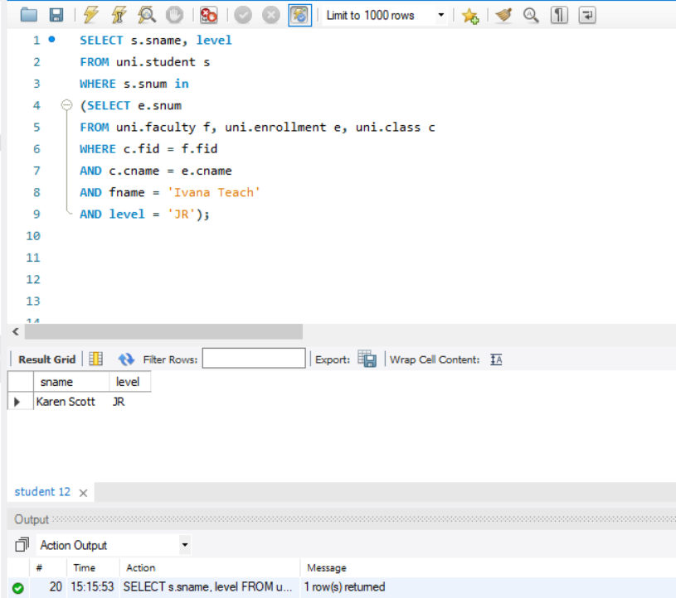

## Find the names of faculty members that has taught classes only in room R128.

SELECT fname

FROM uni.faculty f

WHERE f.fid IN

(SELECT c.fid FROM uni.class c

WHERE c.fid NOT IN

(SELECT c.fid FROM class c

WHERE NOT c.room ='R128'));

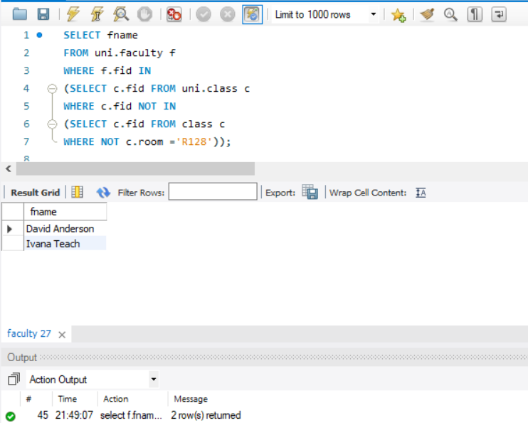

## Find the names of classes taught by ‘Richard Jackson’ and their times when a class meet there.

SELECT c.cname, c.meets_at

FROM uni.class c

WHERE c.fid in

(SELECT f.fid

FROM uni.faculty f

WHERE f.fid = c.fid

AND f.fname = 'Richard Jackson');

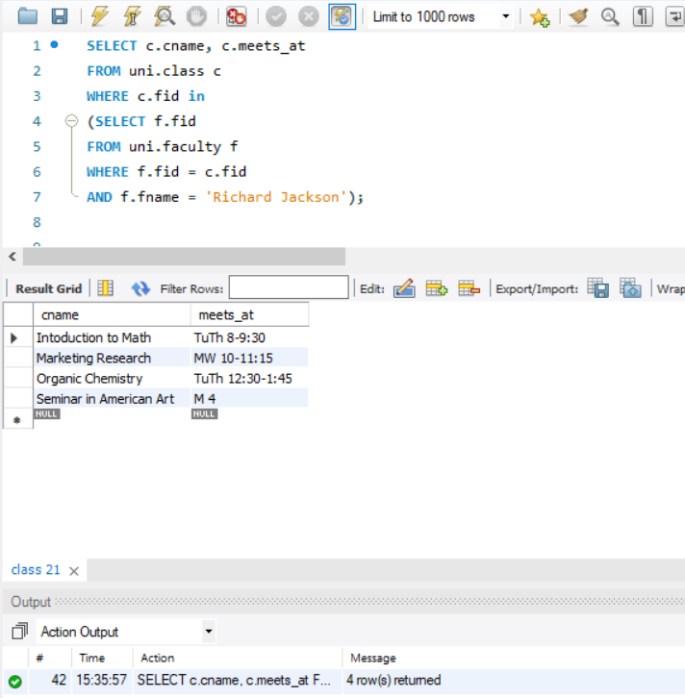

## Find the names of students majoring in ‘Computer Science’.

SELECT sname, major

FROM uni.student s

WHERE s.snum in

(SELECT s.snum

FROM uni.student s

WHERE s.major = 'Computer Science');

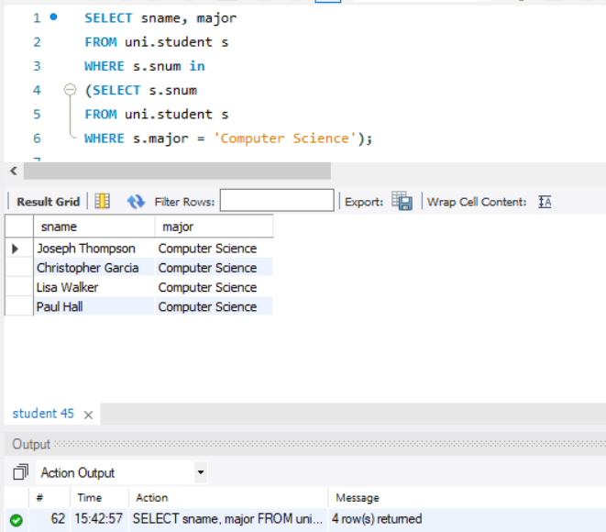

## Find the names of classes taught by ‘John Williams’ in dept # 68..

SELECT cname, c.fid

FROM uni.class c

WHERE c.fid in

(SELECT f.fid

FROM uni.faculty f

WHERE c.fid = f.fid

AND fname = 'John Williams'

AND deptid = 68);

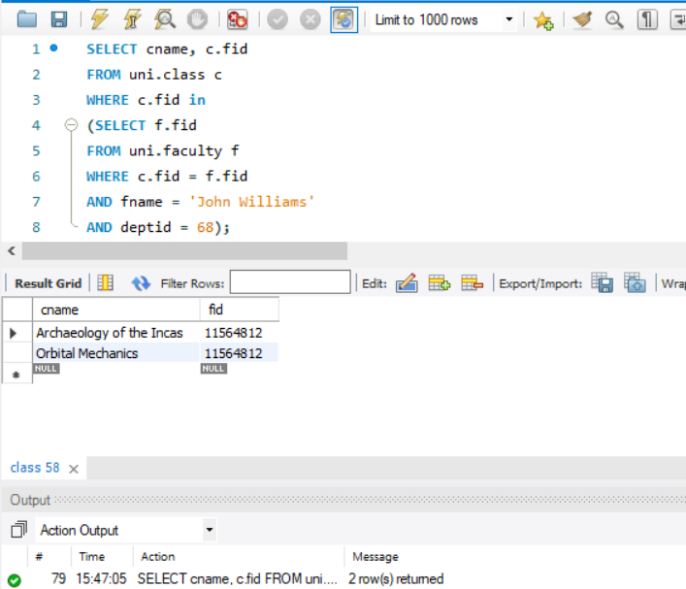

## Find the names of students in ‘Computer Science’ major in descending age-wise.

SELECT sname, major, age

FROM uni.student s

WHERE s.snum in

(SELECT s.snum

FROM uni.student s

WHERE s.major = 'Computer Science')

ORDER BY age desc;

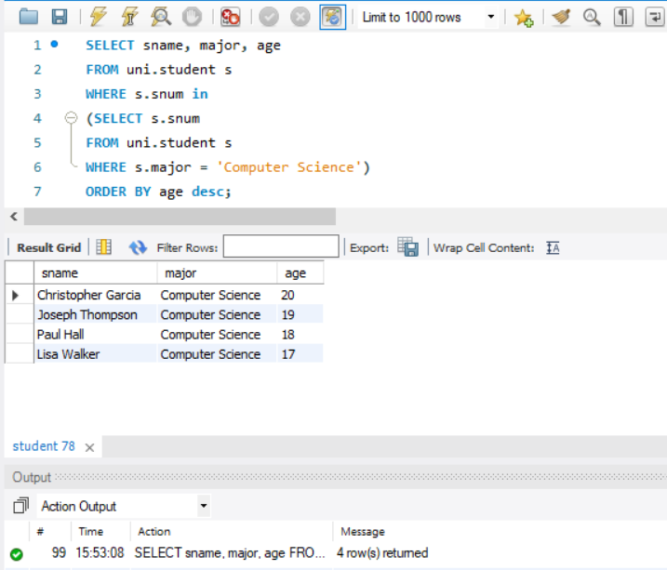

## Find distinct student ages in ‘Database Systems’ class in descending order.

SELECT DISTINCT age

FROM uni.student s

WHERE s.snum in

(SELECT e.snum

FROM uni.enrollment e

WHERE e.cname = 'Database Systems')

ORDER BY age desc;

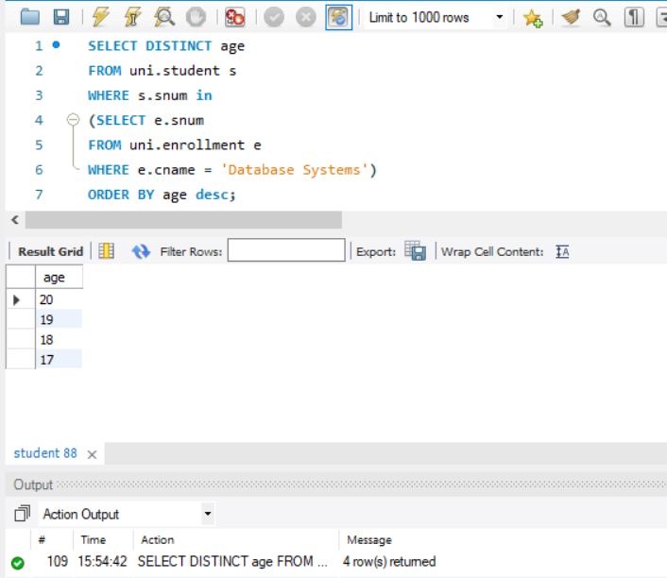

## List the name of ‘Christopher Garcia’s teachers.

SELECT fname

FROM uni.faculty f

WHERE f.fid in

(SELECT c.fid

FROM uni.student s, uni.class c, uni.enrollment e

WHERE s.sname = 'Christopher Garcia'

AND s.snum = e.snum

AND c.cname = e.cname);

